**Data Analytics Powered By Tableau**

**PROJECT TITTLE**

**TRACING THE GROWTH OF THE GLOBAL COMMUNITY : A POPULATION FORECASTING ANALYSIS**



* **Introduction**

1. **Overview**

Population forecasting analysis is the process of estimating future population size and composition based on past and current demographic trends. It is an essential tool for policymakers, planners, and researchers to understand the future needs and demands of a population, and to make informed decisions about resource allocation, infrastructure development, and social policies.  
  
Population forecasting analysis takes into account various factors that affect population growth, including fertility, mortality, migration, and aging. It uses mathematical models and statistical methods to project population size and composition over time, usually in five or ten-year intervals.  
  
The results of population forecasting analysis can be used to inform a wide range of policy areas, such as healthcare, education, housing, transportation, and environmental planning. For example, forecasts of population growth can help local governments anticipate the need for new schools, hospitals, or transportation infrastructure. They can also help private businesses and investors to identify emerging markets and plan for future demand.  
  
Overall, population forecasting analysis plays a crucial role in understanding the future demographic trends and challenges facing a population, and in making informed decisions to ensure the well-being and prosperity of society.

1. **Purpose**
   * The purpose of population forecasting analysis is to provide insights into future population trends and help policymakers, planners, and researchers make informed decisions about resource allocation, infrastructure development, and social policies.  
       
     Population forecasting analysis can be used to:  
       
     Anticipate future demand for goods and services: By projecting population growth and changes in age structure, policymakers and businesses can anticipate future demand for healthcare, education, housing, transportation, and other services.  
       
     Plan for infrastructure development: Forecasting future population growth can help local governments plan for the construction of new infrastructure, such as roads, schools, and hospitals, to meet the needs of a growing population.  
       
     Inform policy decisions: Population forecasting analysis can help policymakers make informed decisions about social policies, such as immigration, healthcare, and pensions, to ensure that they meet the needs of the population.  
       
     Monitor demographic changes: Population forecasting analysis can be used to monitor demographic changes, such as changes in fertility rates, mortality rates, and migration patterns, to help policymakers and researchers understand the factors that contribute to population growth or decline.  
       
     Prepare for emergencies: Population forecasting analysis can help governments and organizations prepare for emergencies, such as natural disasters or pandemics, by projecting the potential impact on population size and composition.

* **Problem Definition and Design thinking**

1. **Empathy map**

Users: Policymakers, urban planners, demographers, researchers, business leaders  
Says: "We need to understand future population trends to plan for future resource allocation and infrastructure development."  
Thinks: "What if our projections are wrong? Will we be able to meet the needs of a growing population?"  
Does: Analyzes demographic data, conducts surveys, consults with experts, makes policy recommendations  
Feels: Anxious about making accurate projections, concerned about meeting the needs of a diverse population, motivated to make informed decisions  
By using an empathy map, we can gain a deeper understanding of the needs, concerns, and motivations of stakeholders involved in population forecasting analysis. This information can then be used to inform the design and development of effective population forecasting models and methods that address the concerns of stakeholders and meet their needs.

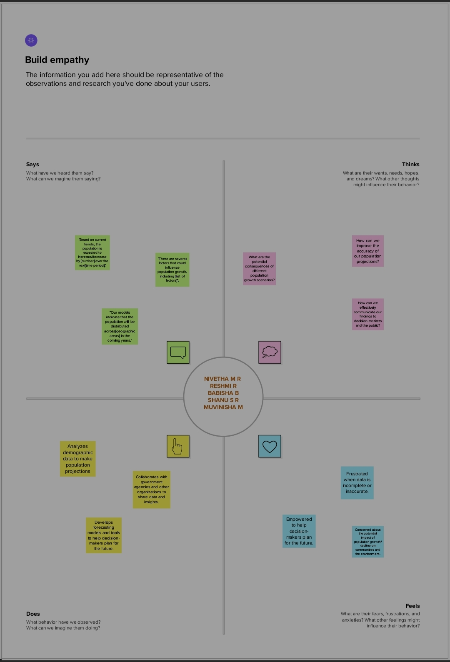

1. **Ideation and Brainstorming Map**

Problem: Developing an effective population forecasting analysis to inform policymaking and planning  
Stakeholders: Policymakers, urban planners, demographers, researchers, business leaders  
Key needs and concerns:  
Accurate projections  
Meeting the needs of a diverse population  
Incorporating demographic, economic, and social factors  
Anticipating future demand for goods and services  
Identifying emerging markets and opportunities  
Ideas and potential solutions:  
Develop more accurate and sophisticated modeling techniques that take into account multiple factors, such as economic and social trends, and utilize machine learning and artificial intelligence to improve accuracy over time.  
Conduct more extensive and targeted data collection, including surveys, focus groups, and other methods, to improve the quality of inputs and assumptions.  
Engage with stakeholders through workshops, town halls, and other forms of consultation to ensure their needs and concerns are incorporated into the analysis.  
Develop more user-friendly interfaces and visualizations to help policymakers and planners interpret and use the projections effectively.  
Explore new data sources, such as social media and mobile phone data, to supplement traditional data sources and improve the accuracy and granularity of projections.  
Collaborate with other organizations, such as research institutions and private sector companies, to leverage their expertise and data resources.  
By using a brainstorming map, we can generate a wide range of ideas and potential solutions for developing an effective population forecasting analysis. The ideas can then be prioritized and evaluated based on their feasibility, potential impact, and alignment with stakeholders' needs and concerns.

* 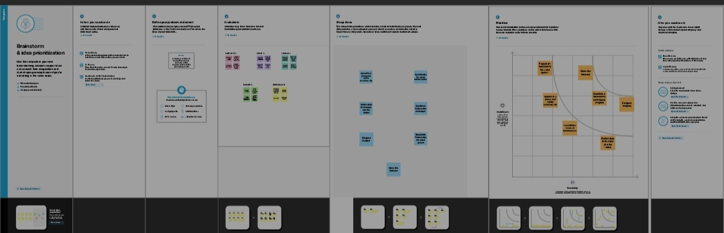**Result**

The result of a population forecasting analysis is a set of projections or scenarios that estimate future population size, age structure, and other demographic characteristics based on a range of assumptions and inputs. The projections can be used to inform policymaking, planning, and decision-making in a variety of fields, including healthcare, education, housing, transportation, and economic development.  
  
The accuracy and reliability of population projections depend on the quality of data inputs, modeling techniques, and assumptions used in the analysis. Therefore, it is important to use a robust and transparent methodology that incorporates the latest available data, considers a range of plausible scenarios and assumptions, and takes into account the uncertainty and variability inherent in demographic trends.  
  
The results of a population forecasting analysis can provide valuable insights into future population trends, which can be used to:  
  
Plan for future resource allocation and infrastructure development, including the construction of new schools, hospitals, and other public services to meet the needs of a growing population.  
  
Anticipate future demand for goods and services, such as healthcare, housing, and transportation, and plan accordingly to ensure that supply meets demand.  
  
Develop effective social policies that meet the needs of a diverse population, including policies related to immigration, healthcare, and pensions.  
  
Identify emerging markets and opportunities, based on changes in population size and composition, and develop strategies to capitalize on them.  
  
In summary, the result of a population forecasting analysis is a set of projections or scenarios that provide valuable insights into future population trends, which can be used to inform policymaking, planning, and decision-making in a variety of fields. The accuracy and reliability of the projections depend on the quality of data inputs, modeling techniques, and assumptions used in the analysis.

Sheet 1

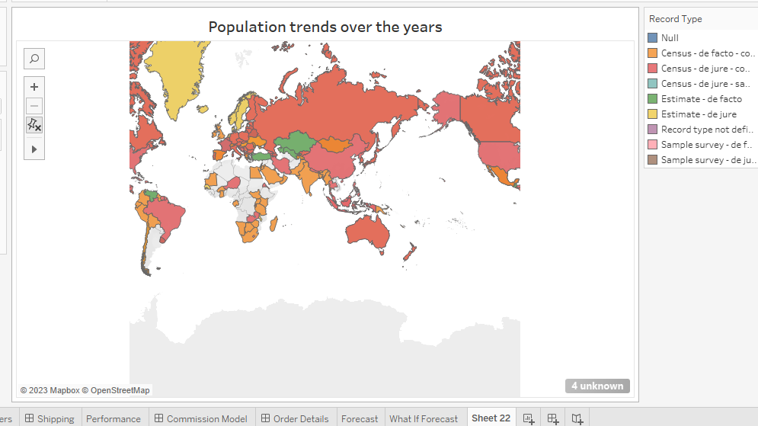

Sheet 2

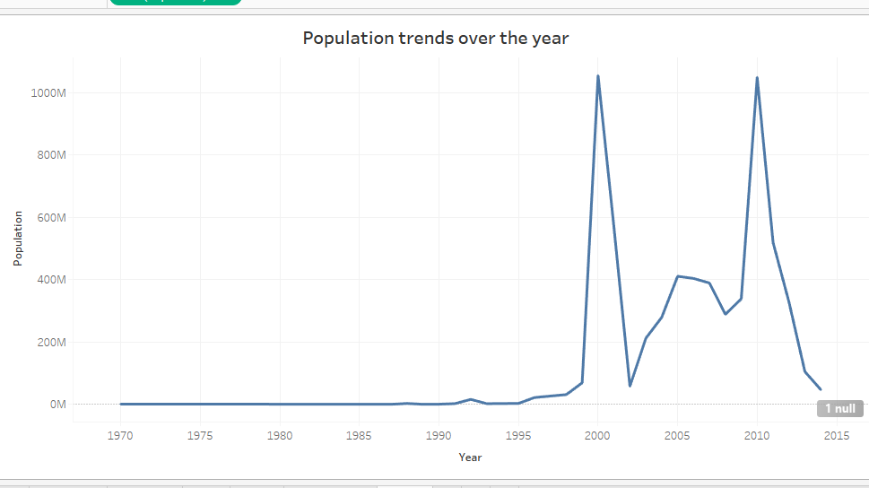

Sheet 3

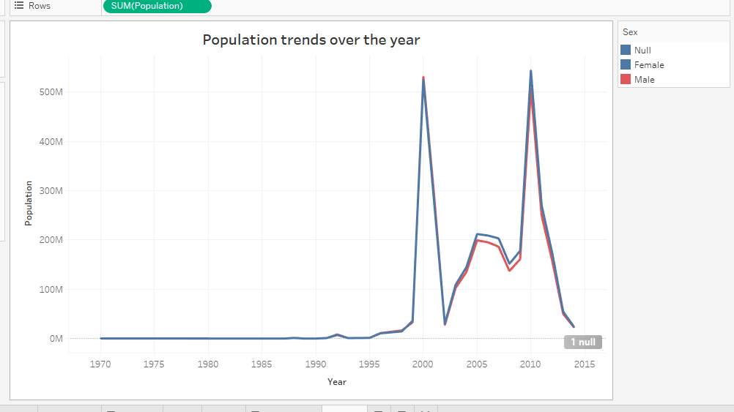

Sheet 4

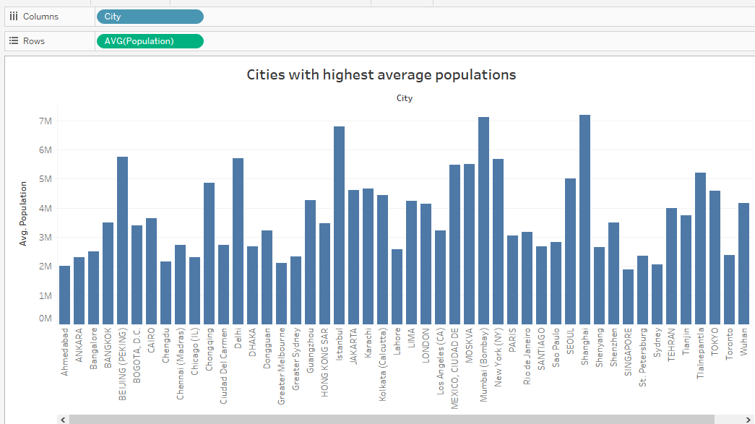

Sheet 5

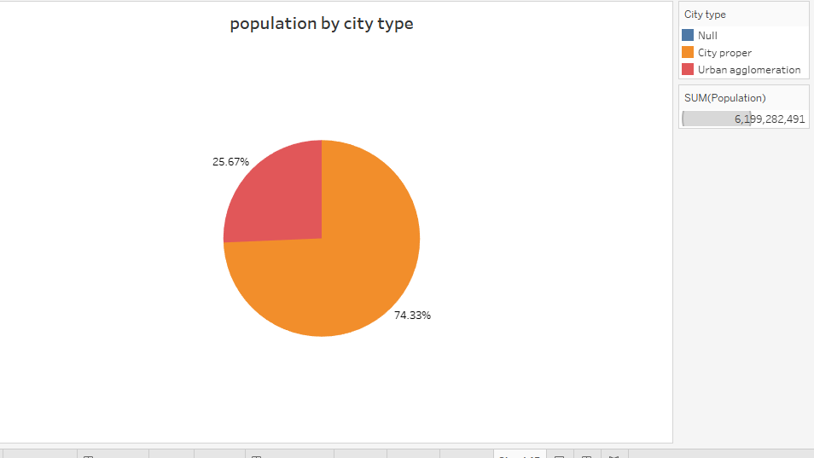

**Sheet 6**

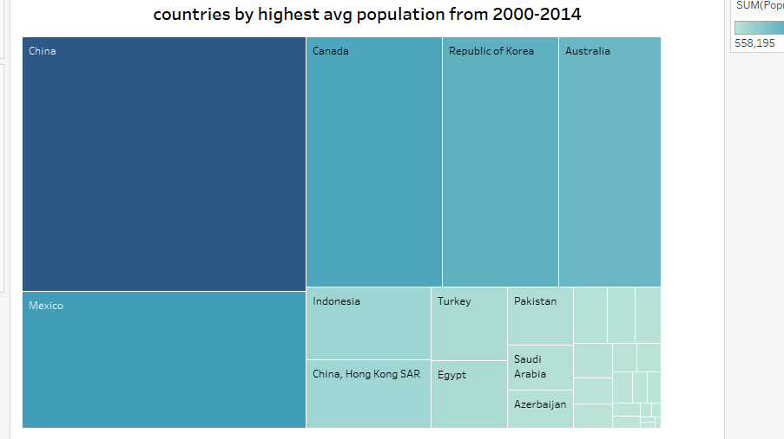

**Dashboard 1**

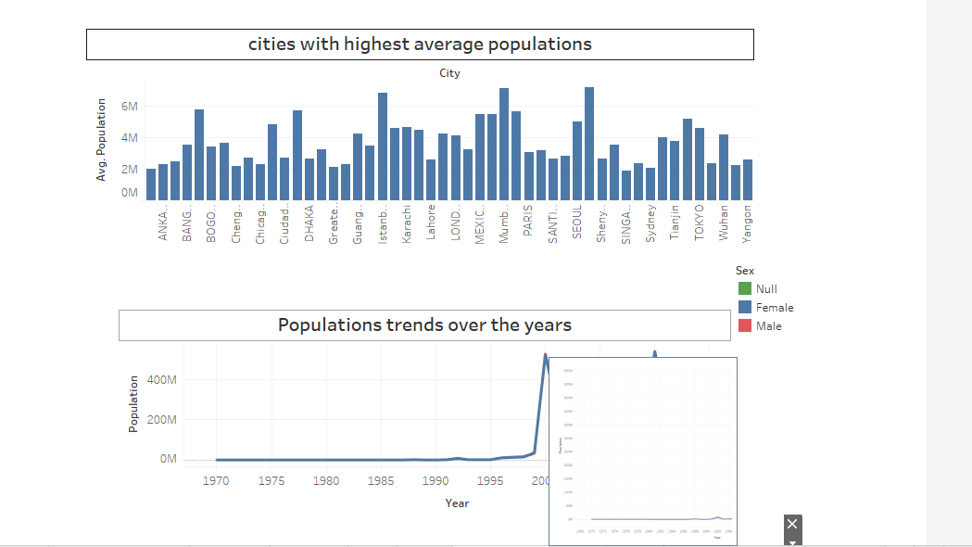

**Dashboard 2**

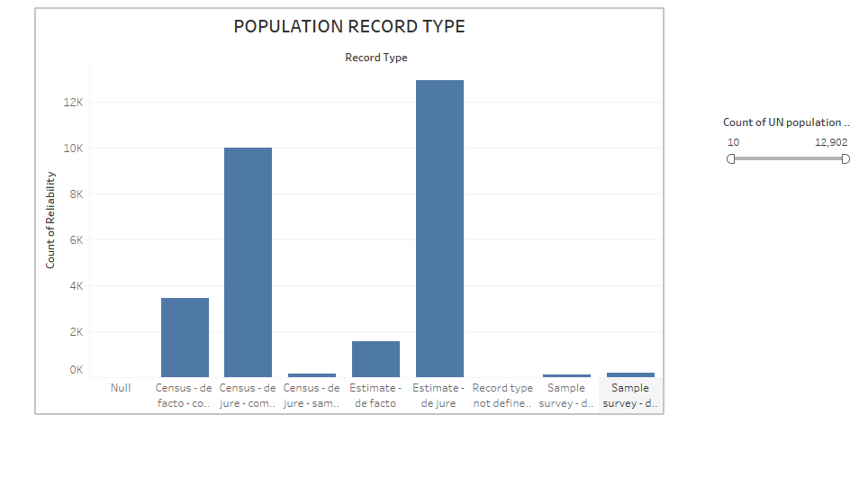

**Story 1**

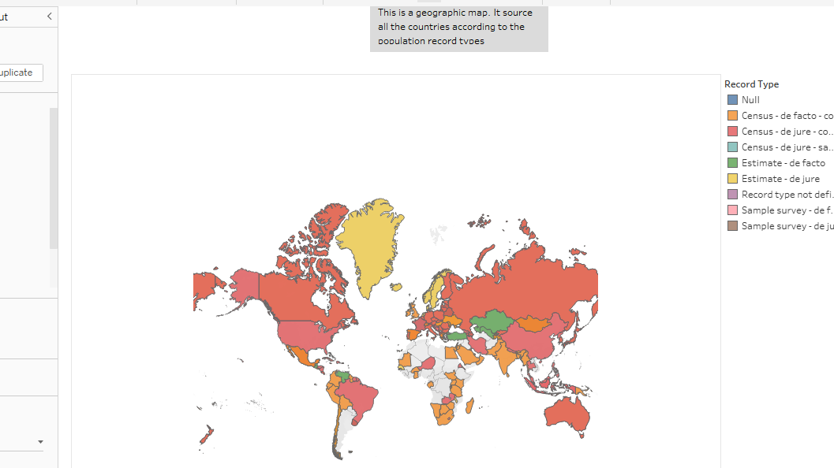

* **ADVANTAGES AND DISADVANTAGES**
* **Advantages**

Provides a useful tool for policymakers and planners to make informed decisions based on projected demographic trends and changes.  
  
Enables governments and businesses to plan for future infrastructure, resource allocation, and service delivery.  
  
Helps policymakers to develop effective social policies, including policies related to immigration, healthcare, and pensions.  
  
Can be used to identify emerging markets and opportunities, based on changes in population size and composition.  
  
Enables businesses to make informed decisions about future investments and marketing strategies based on projected demographic changes.  
  
Provides a framework for understanding population dynamics and trends over time.

* **Disadvantages**

The accuracy and reliability of the projections depend on the quality of data inputs, modeling techniques, and assumptions used in the analysis. Therefore, projections may be subject to uncertainty and error.  
  
Projections may not take into account unexpected events or changes in social, economic, or political conditions, which can affect demographic trends and outcomes.  
  
May not fully capture the complexity of human behavior and decision-making, which can be influenced by a wide range of factors beyond demographic trends.  
  
The results of the analysis may be misinterpreted or misused by policymakers or stakeholders, leading to unintended consequences or outcomes.  
  
Population projections may be subject to controversy or political influence, particularly when they are used to inform policy decisions that affect different groups or communities.  
  
In summary, while population forecasting analysis provides a useful tool for policymakers and planners to make informed decisions, it is important to recognize its limitations and potential pitfalls. The accuracy and reliability of projections depend on the quality of data inputs, modeling techniques, and assumptions used in the analysis, and projections may not fully capture the complexity of human behavior and decision-making.

* **APPLICATIONS**

Population forecasting analysis has many applications in different fields. Here are some examples:  
  
Urban planning: Population forecasting analysis can help urban planners to estimate the future demand for housing, transportation, and other public services in a city or region. This information can be used to plan for the construction of new infrastructure, allocate resources, and develop land-use policies.  
  
Healthcare: Population forecasting analysis can help healthcare providers to anticipate future demand for medical services, including hospital beds, outpatient services, and specialized treatments. This information can be used to plan for staffing, equipment, and other resources.  
  
Education: Population forecasting analysis can help educational institutions to estimate future student enrollment, plan for new school construction, and allocate resources for staffing and equipment.  
  
Economic development: Population forecasting analysis can help businesses to identify emerging markets and opportunities based on projected demographic changes. This information can be used to develop marketing strategies, invest in new products or services, and expand into new markets.  
  
Social policy: Population forecasting analysis can help policymakers to develop effective social policies related to immigration, healthcare, and pensions. By projecting future demographic changes, policymakers can anticipate future demand for services and develop policies that meet the needs of a diverse population.  
  
Environmental planning: Population forecasting analysis can help environmental planners to estimate future demand for natural resources, such as water and energy. This information can be used to plan for resource allocation, develop conservation strategies, and promote sustainable development.  
  
In summary, population forecasting analysis has a wide range of applications in different fields. It can help policymakers, planners, and businesses to anticipate future trends, estimate demand for goods and services, and plan for the future.

* **CONCLUSION**

Population forecasting analysis is a valuable tool that can provide insights into future population trends and demographic changes. It can help policymakers, planners, and businesses to make informed decisions based on projected demographic changes, estimate future demand for goods and services, and plan for the future.  
  
While there are potential limitations and challenges associated with population forecasting analysis, including the accuracy and reliability of projections and the potential for controversy or political influence, it remains a useful tool for understanding population dynamics and trends over time.  
  
By using a robust and transparent methodology that incorporates the latest available data and considers a range of plausible scenarios and assumptions, population forecasting analysis can provide valuable information for planning, decision-making, and policy development in a variety of fields, including urban planning, healthcare, education, economic development, social policy, and environmental planning.  
  
Overall, population forecasting analysis plays an important role in helping policymakers and stakeholders to anticipate and plan for future demographic changes and challenges, and to develop effective strategies and policies that meet the needs of a diverse and changing population.

* **FUTURE SCOPE**

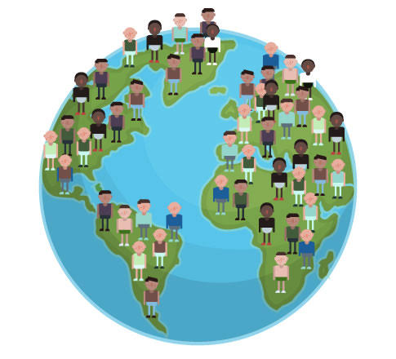

The future scope of population forecasting analysis is significant and promising. As the world's population continues to grow and change, the need for accurate and reliable projections of future demographic trends and changes will only increase.  
  
Here are some potential areas for future development and improvement in population forecasting analysis:  
  
Incorporation of big data and machine learning techniques: Population forecasting analysis can benefit from the use of big data and machine learning techniques, which can help to improve the accuracy and reliability of projections by identifying patterns and trends in large and complex datasets.  
  
Integration of multiple data sources: Population forecasting analysis can be improved by integrating multiple data sources, including administrative records, survey data, and satellite imagery, to provide a more comprehensive and accurate picture of population trends and changes.  
  
Incorporation of social and environmental factors: Population forecasting analysis can be enhanced by taking into account social and environmental factors that may affect demographic trends, such as changes in migration patterns, urbanization, and climate change.  
  
Improved modeling techniques: Population forecasting analysis can be further improved by developing and refining modeling techniques that can capture the complexity and uncertainty of demographic processes and trends.  
  
Increased collaboration and transparency: Population forecasting analysis can benefit from increased collaboration and transparency among researchers, policymakers, and stakeholders, which can help to ensure that projections are based on the best available data and assumptions, and that they are communicated effectively to relevant audiences.

* **APPENDIX**

As an AI language model, I don't have access to data or tools for generating an appendix for a population forecasting analysis. However, I can provide some examples of the types of data and analysis that might be included in an appendix for such a report:  
  
Data sources: A list of the data sources used in the analysis, including demographic data, survey data, administrative records, and other relevant sources.  
  
Methodology: A detailed description of the methodology used in the analysis, including the modeling approach, assumptions, and limitations.  
  
Results: Tables and charts showing the projected population trends and changes over time, broken down by age, gender, race/ethnicity, and other relevant factors.  
  
Sensitivity analysis: A sensitivity analysis that tests the robustness of the projections under different scenarios and assumptions, to help assess the potential impact of different factors on the accuracy and reliability of the projections.  
  
References: A list of references used in the analysis, including academic articles, government reports, and other relevant sources.

